Node js documentation

globals

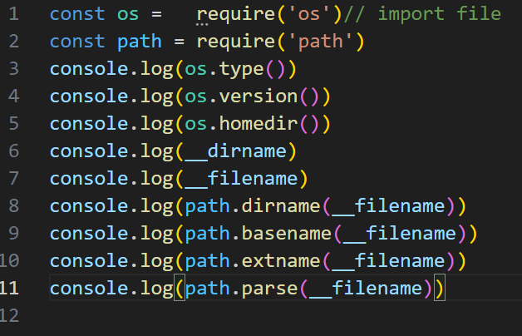

OUTPUT :

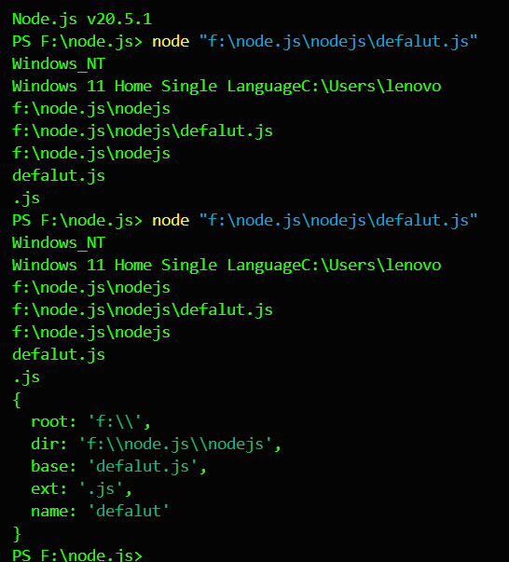

Export inport

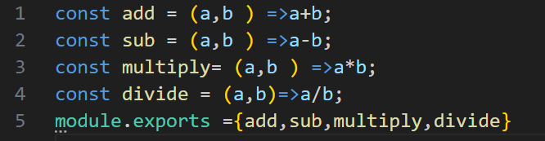

And import it

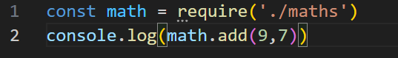

Output

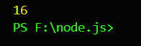

Alternate way of exporting files

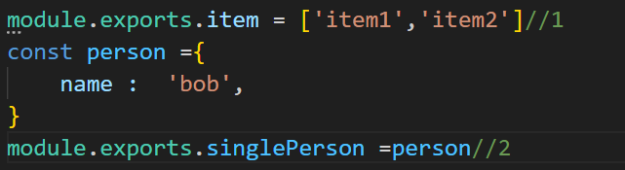

You can invoked a fuction just by impotying it without writing it names

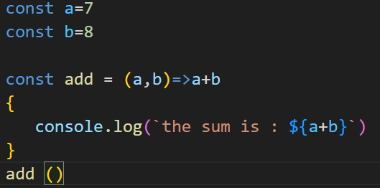

ImprOting



OUTPUT



Built in modulels

Os

Path

Fs

http

os bulid in modulels

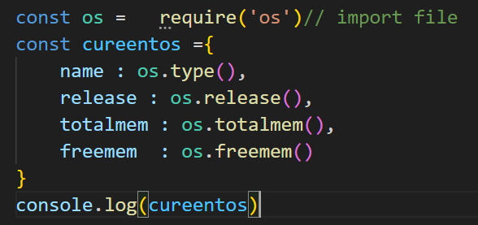

Output

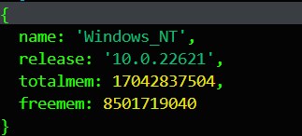

Path modules

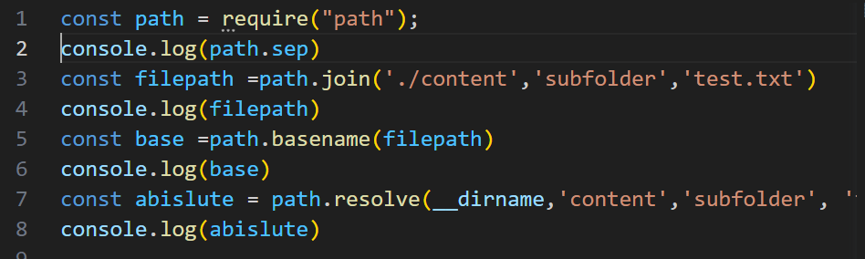

Output

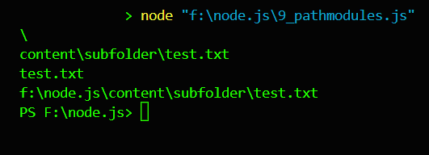

Syncfile

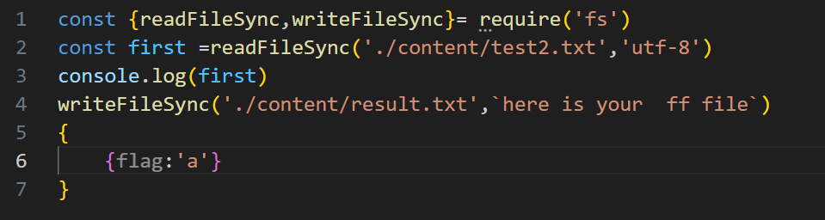

Output

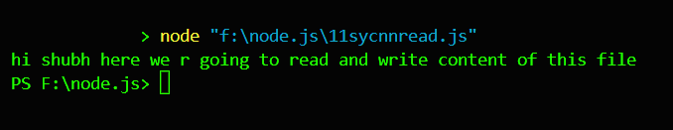

Asyncfileath

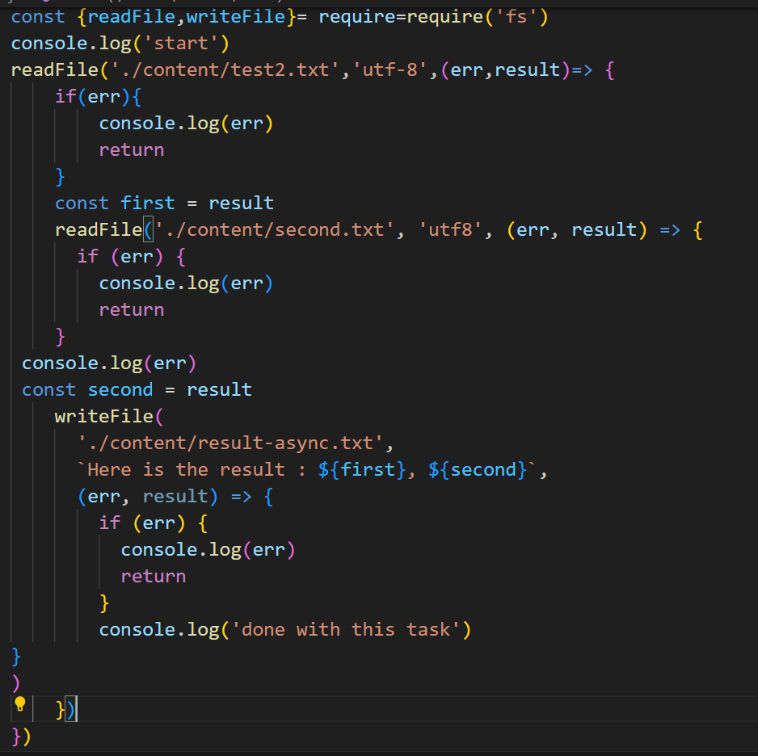

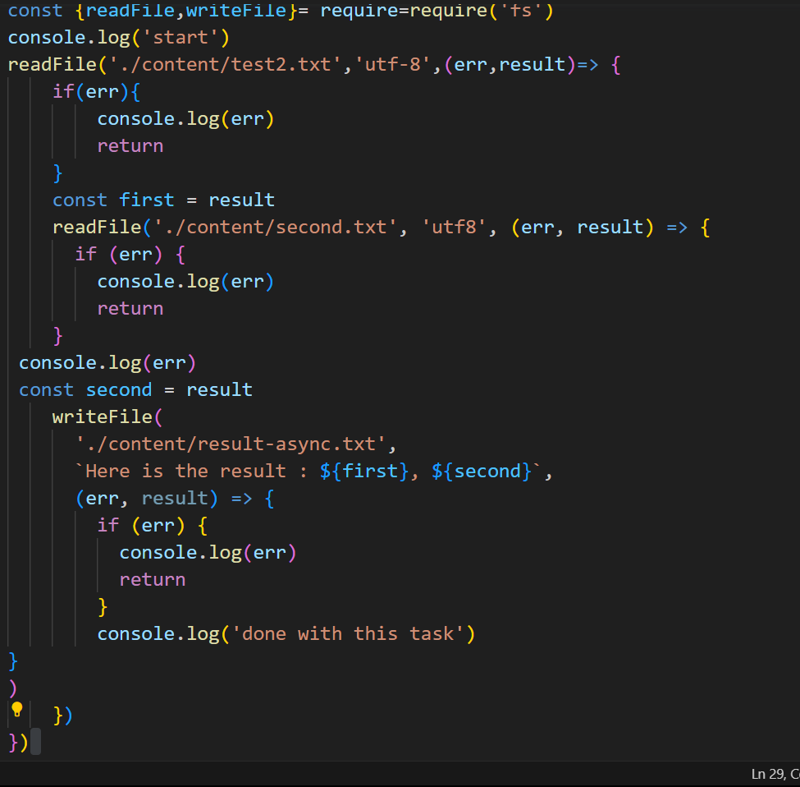

http modules

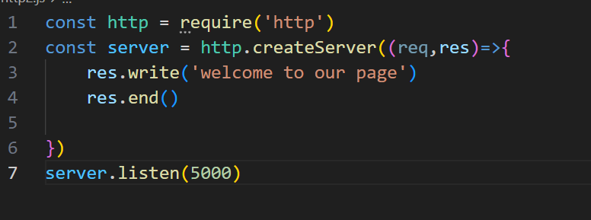

Output

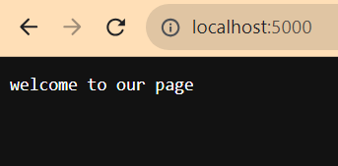

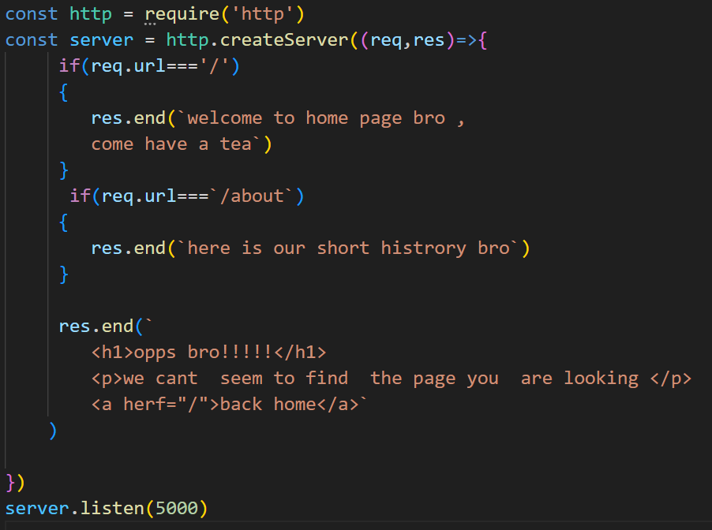

Output

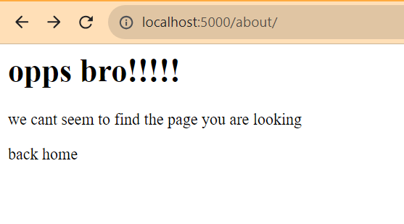

Package modules npm

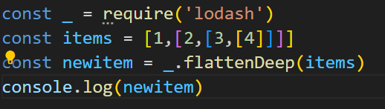

Output

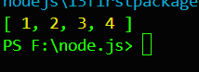

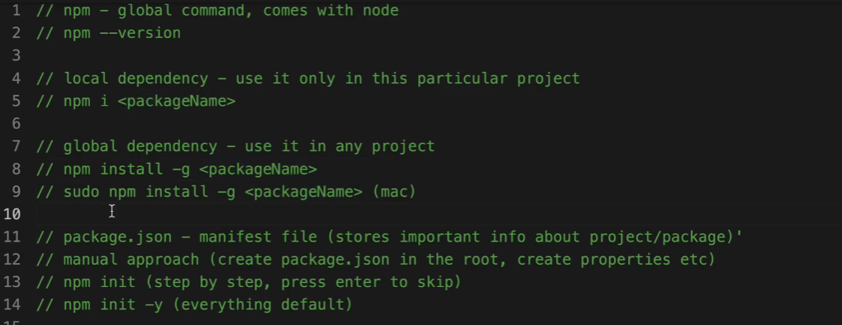

Async event lopps

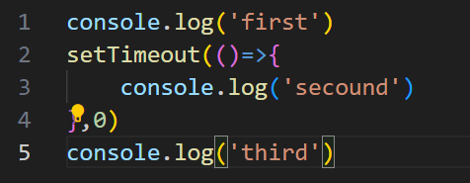

Output

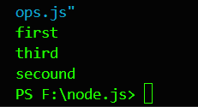

Set interveral

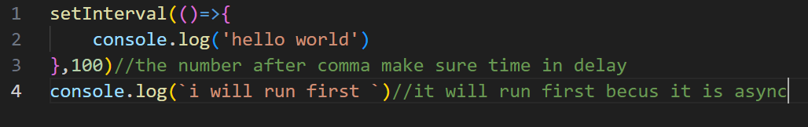

Server listing command

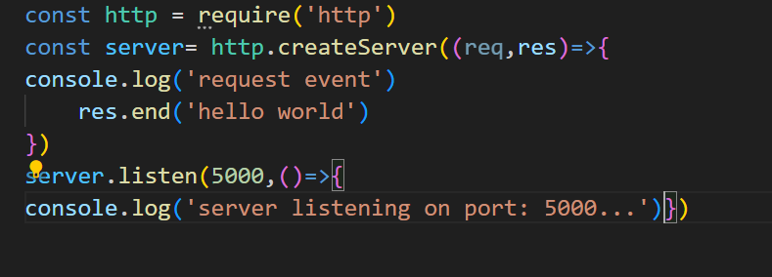

Output

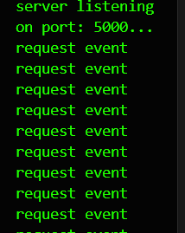

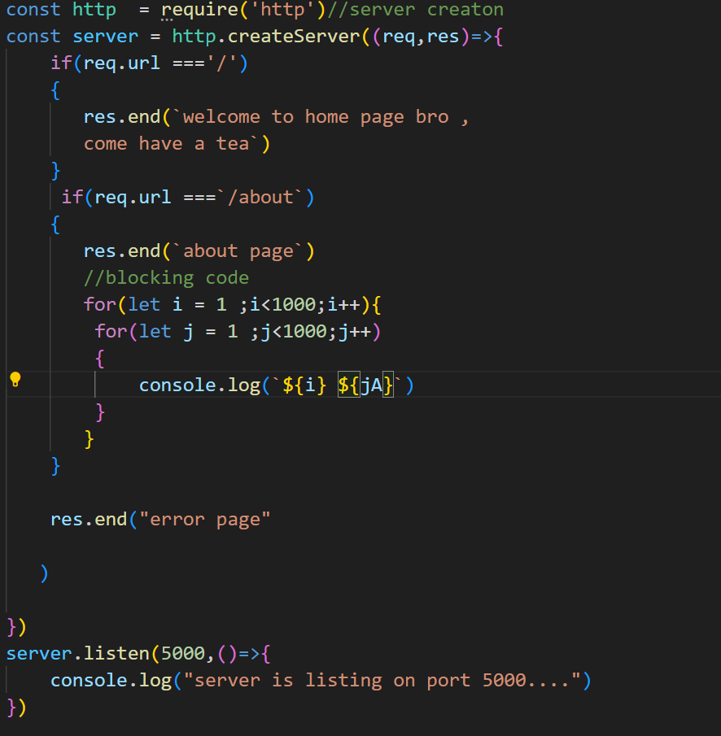

This is code type in sync which is not optimal because for an eg we use blocking code to delay process of one user but it also delay other user process because it was waiting for completing the process of first user which automatically delay other so always write your code in async syntax

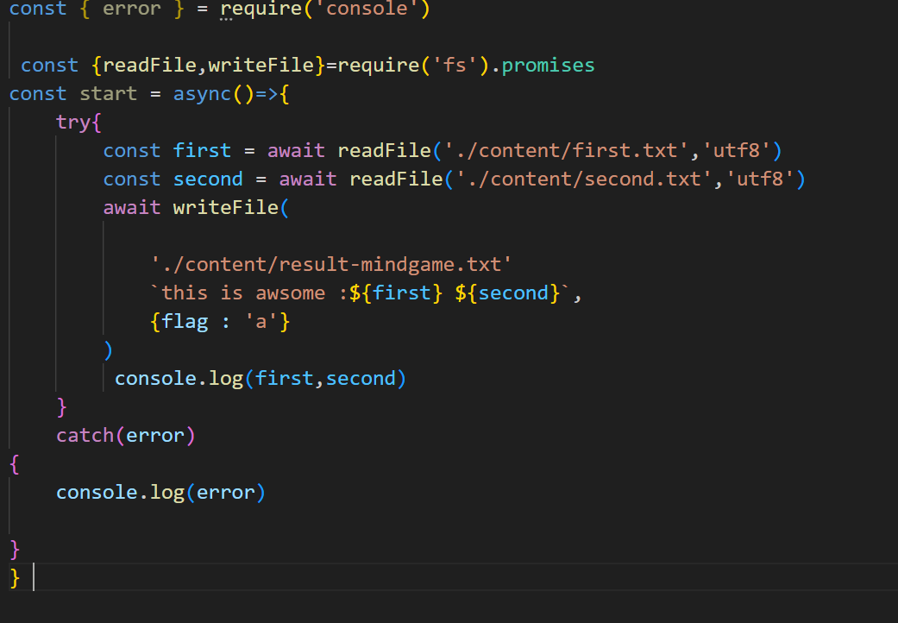

Promise function is use to reduce code size and optimise the call back function

Events

Event driven programming

Use heavy in node.js

How to write events

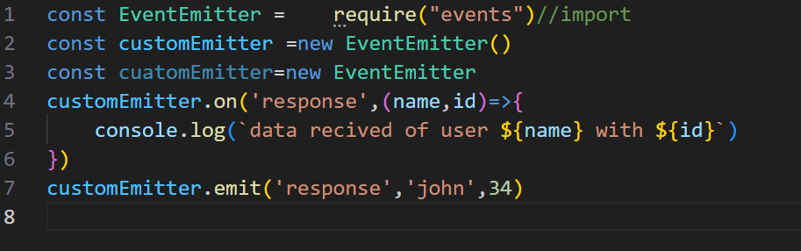 using event emiiter

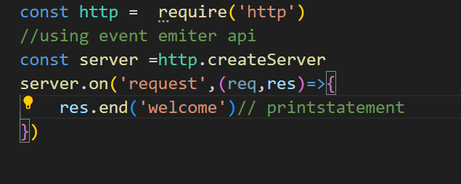

Streams

Inshort read and write function of server

1.writable

2.readable

3.duplex

4.transform

How http and server works syntax of request and response

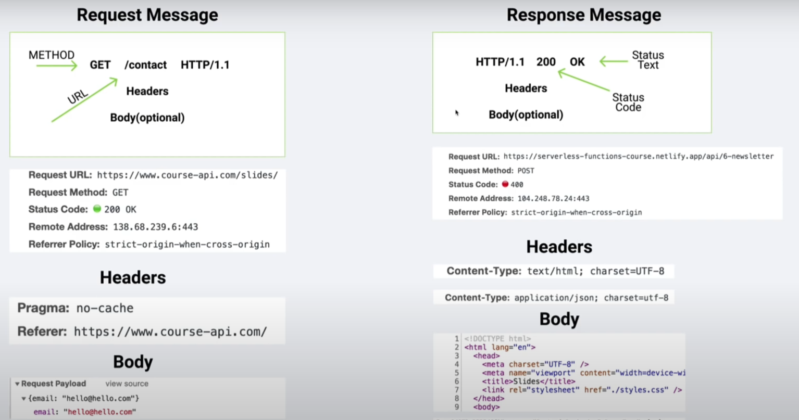 http response status code

https://developer.mozilla.org/en-US/docs/Web/HTTP/Status

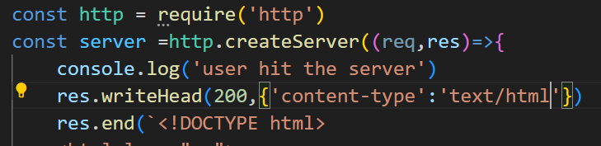

Express.j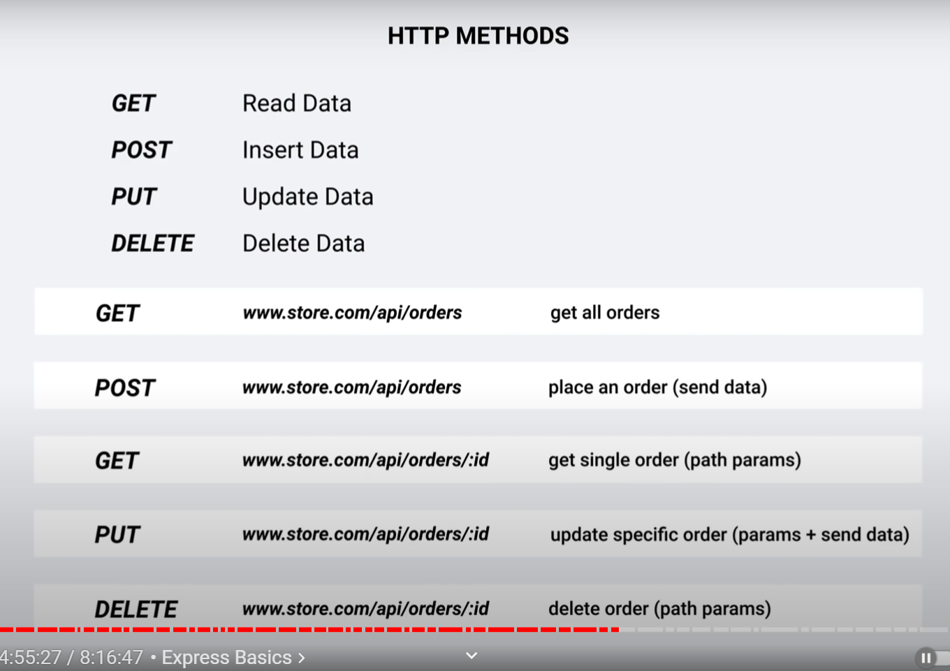s

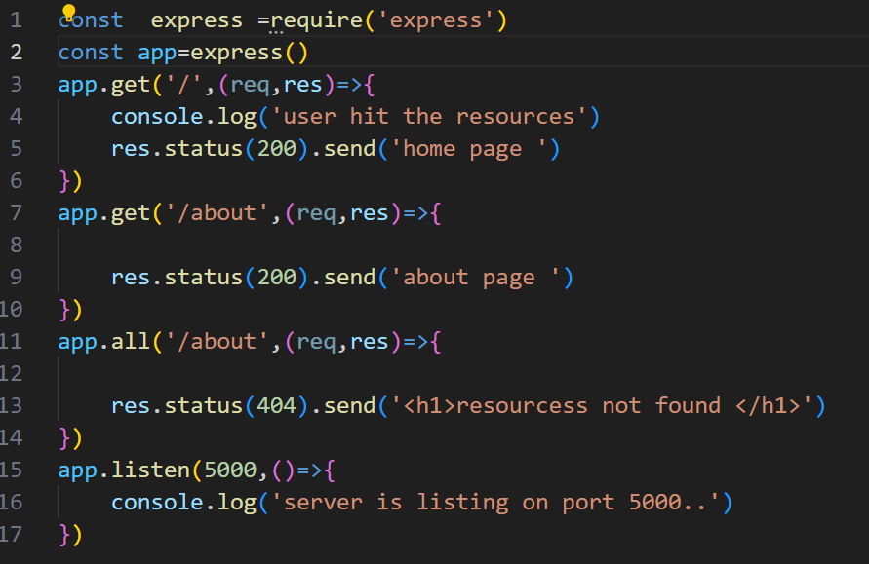  
creation of server in express js

APU VS SSR

   Pa 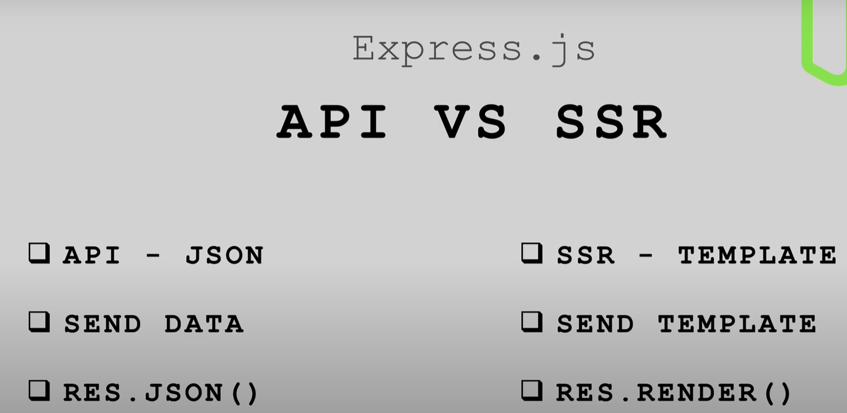

JSON STAND FOR JAVASCRIPT OBJECT NOTATION

Json api

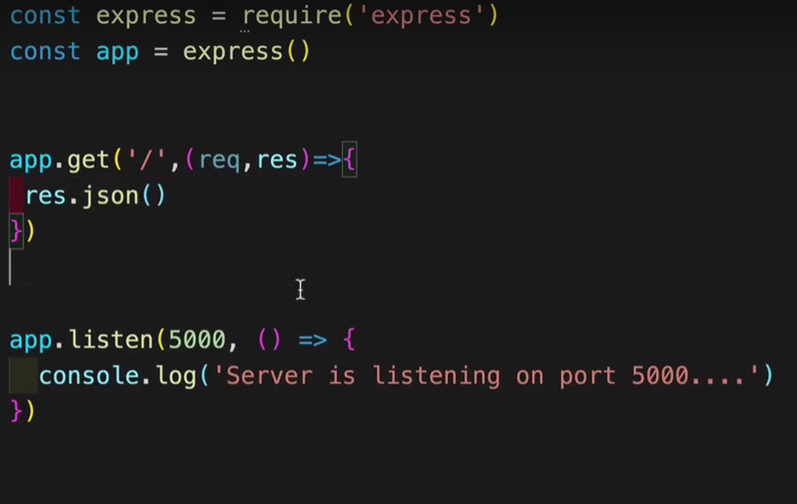

Excessinga data by using product

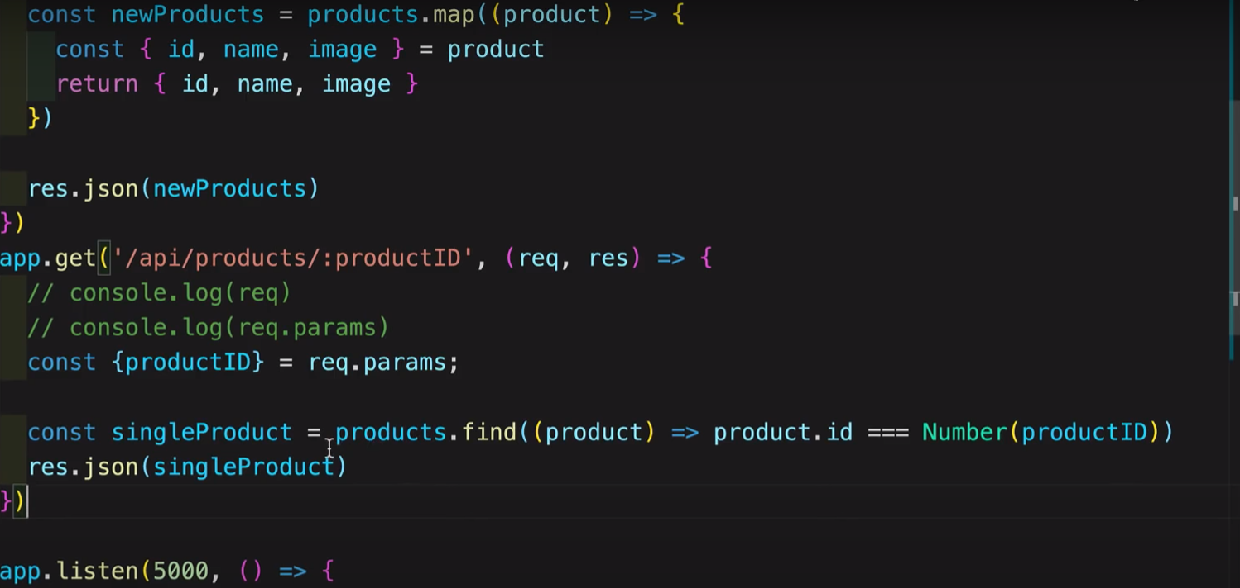

It is also called route paramerter r

Node.js advance

File data transfer and a concept of async

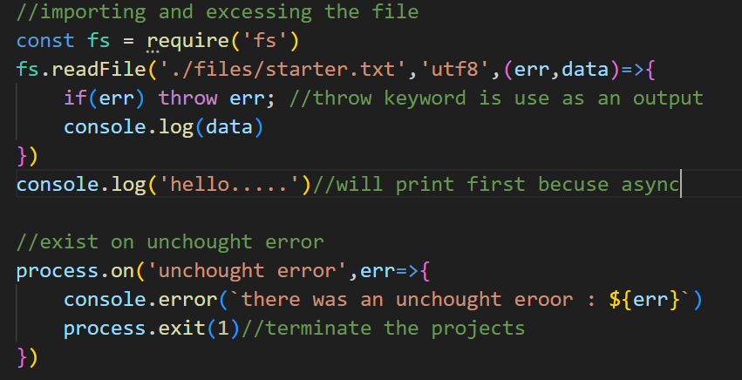

Output :

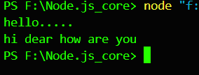

Using path build in modules

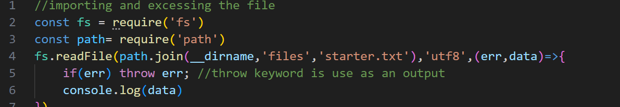

Fs.writefile

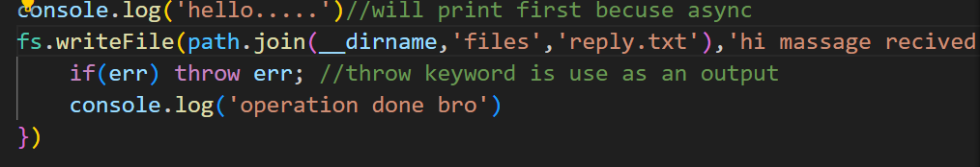

Fs.appendfile



Fs.rename

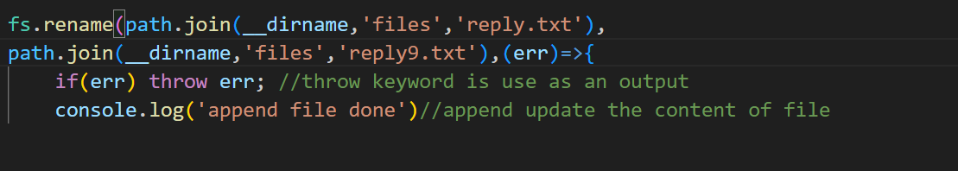

.promise

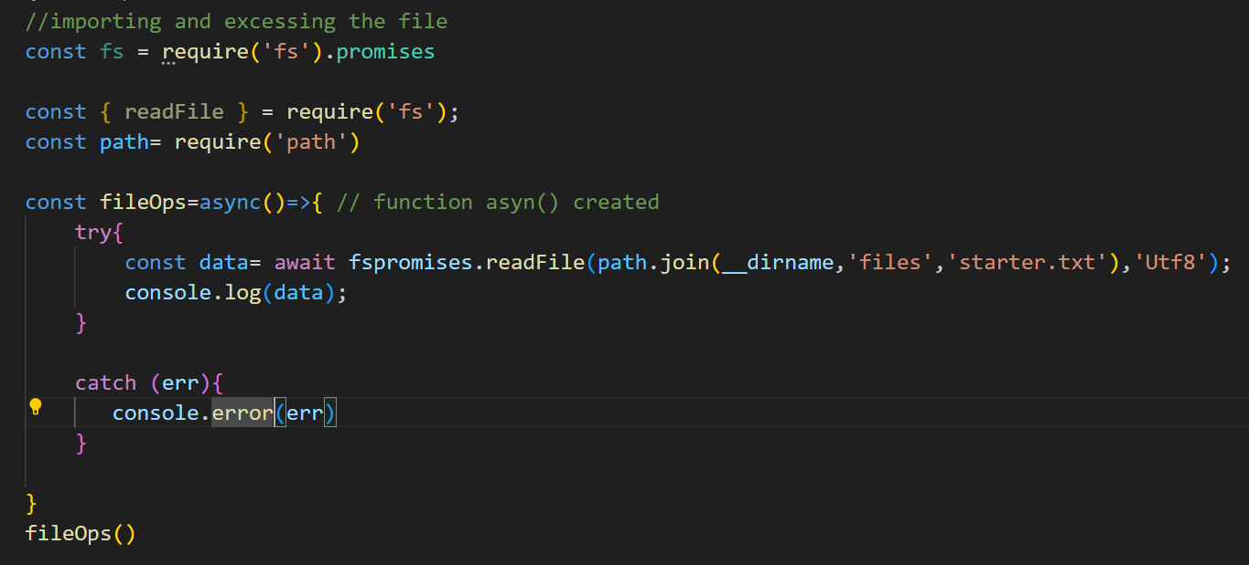

Stream

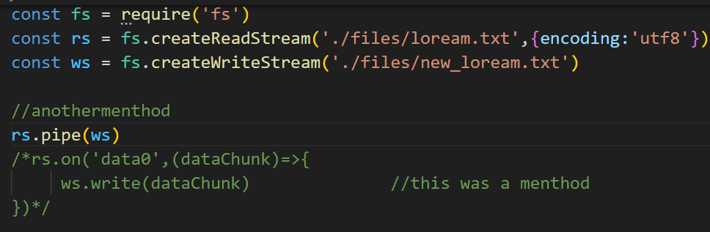

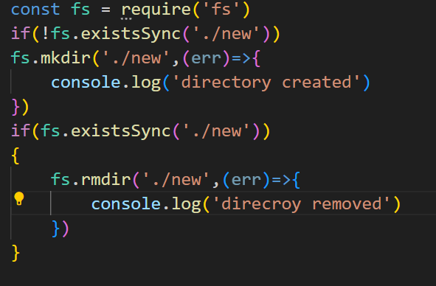

creARt and delete the directory

**npm**

cli – command line interface



How to insall npm

Output

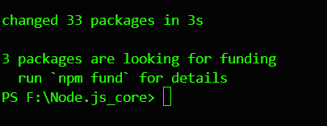

Date and id npm modules

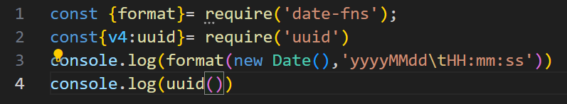

Output

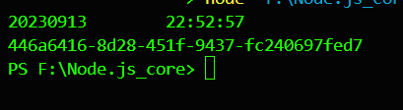

Event emitter

Use make make a log of event happen

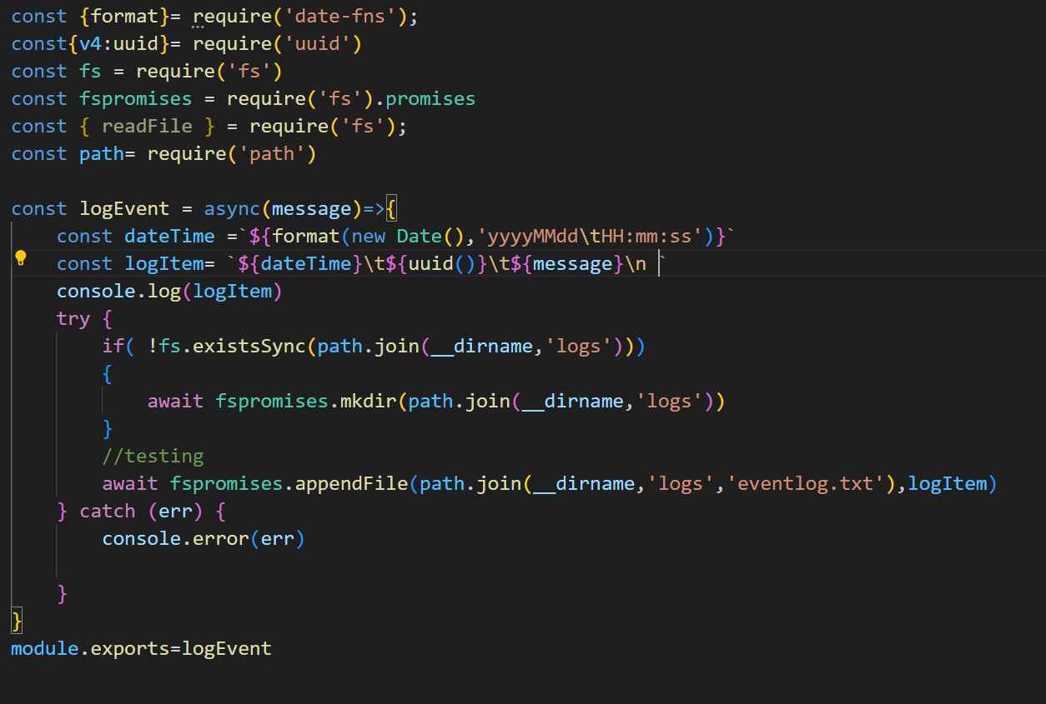

Now file is exported to index.js

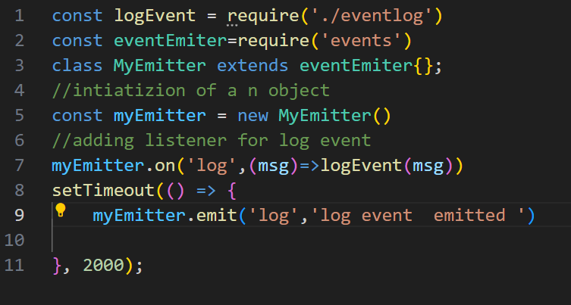

Now output

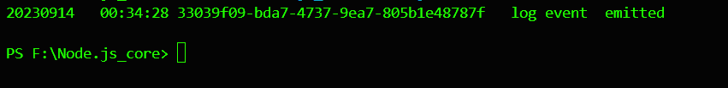

Output

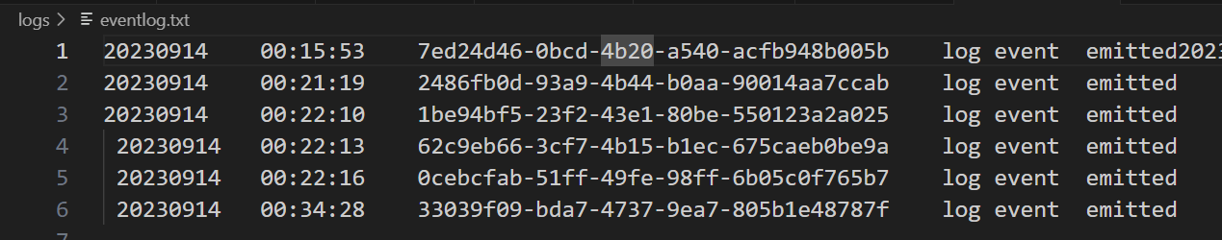

Seeting up the server with nodejs

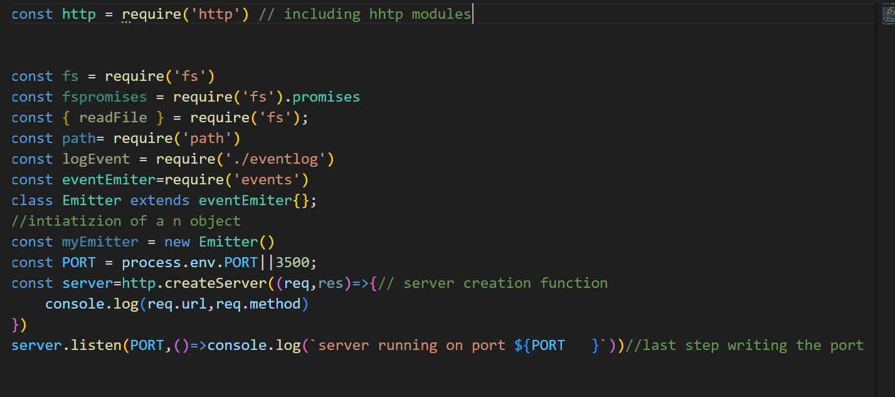output

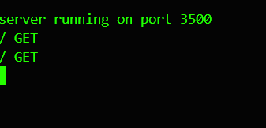

Respond statement alternate code

Method 1 note( let path

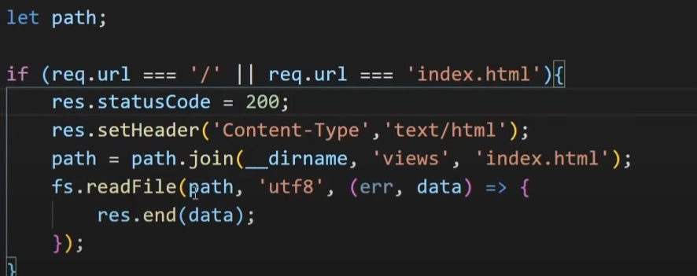

Another method

Using alternating statement

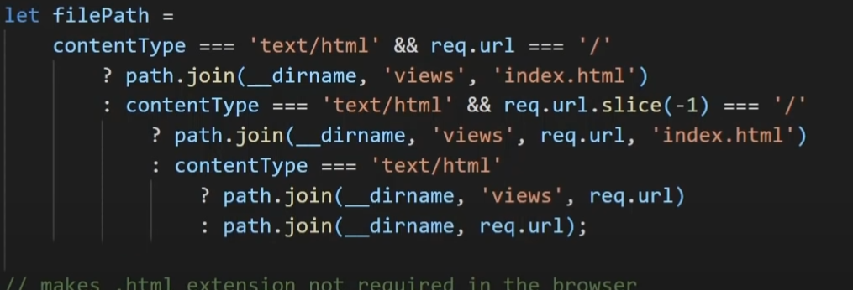\

Setting a dynamic server with node js

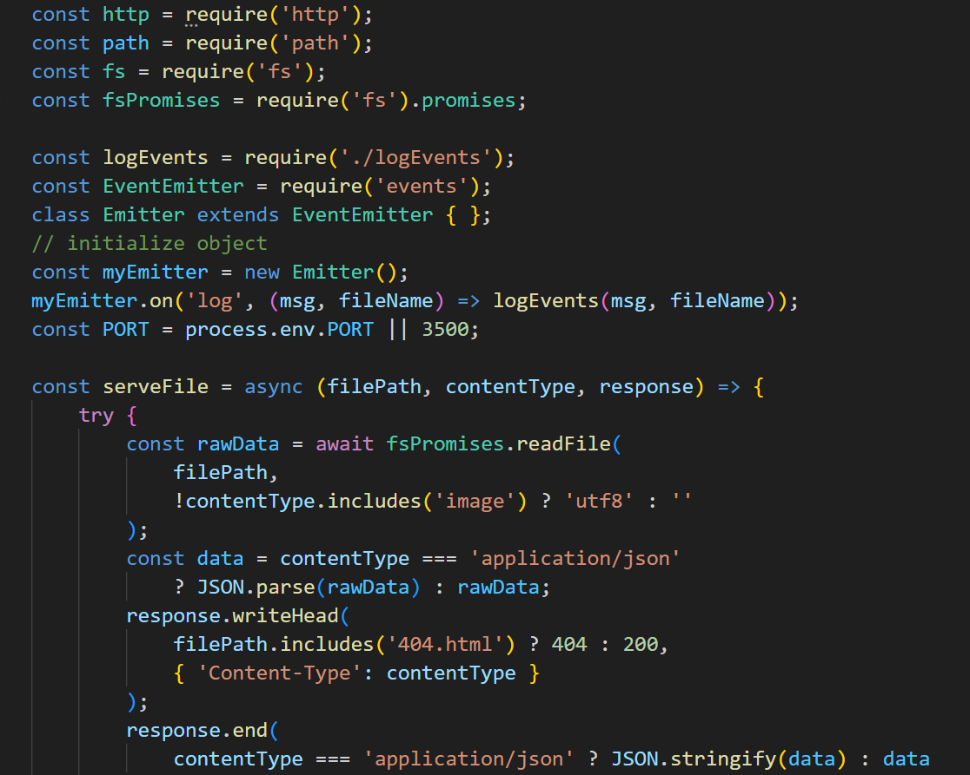

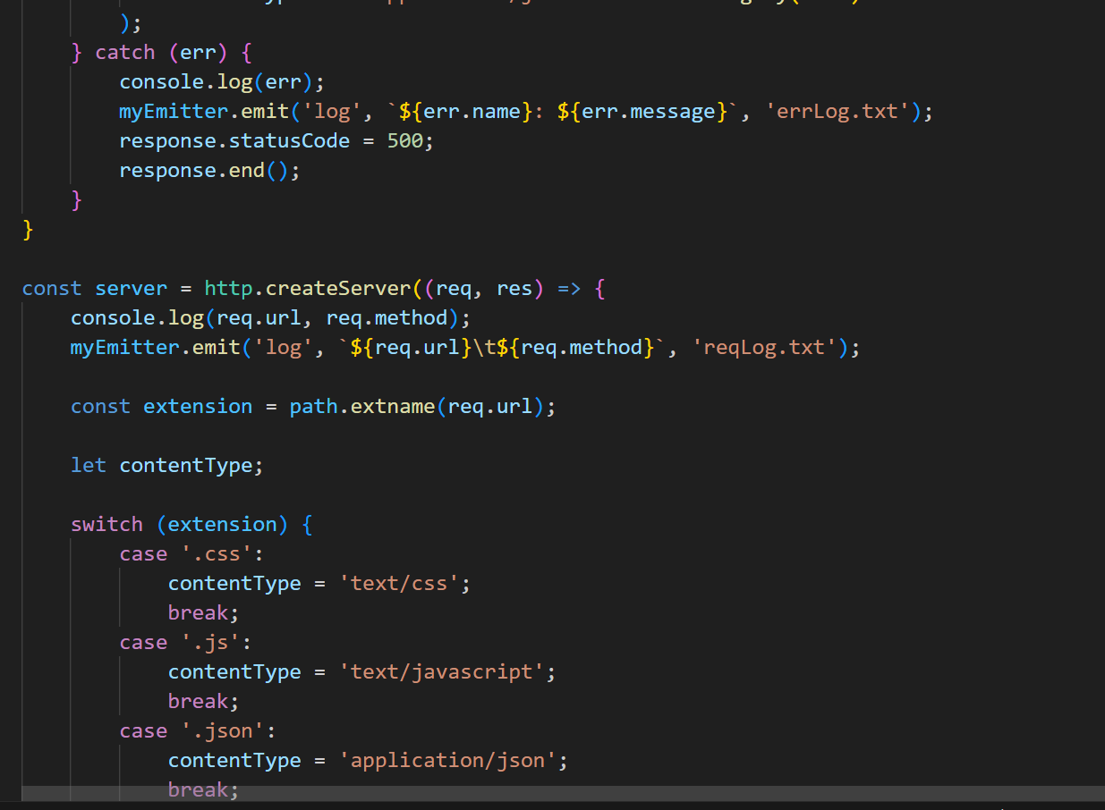

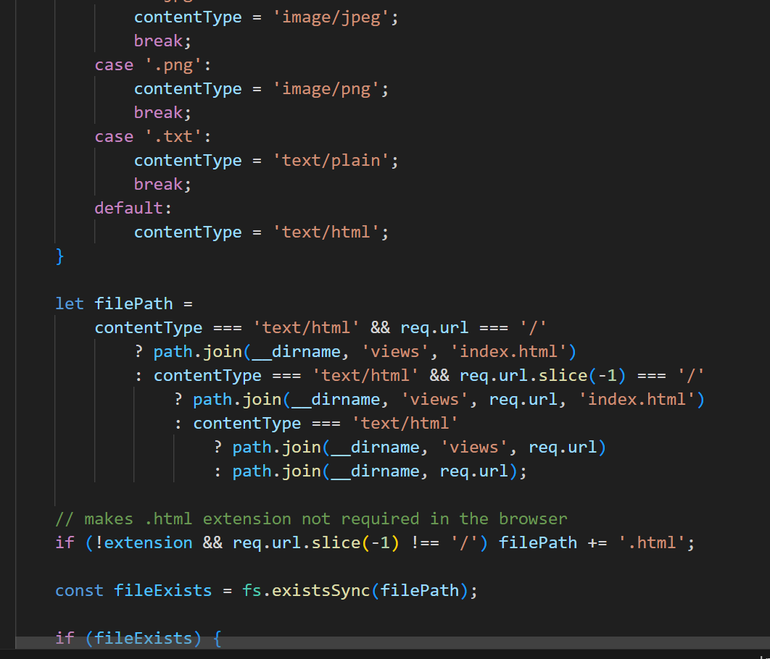

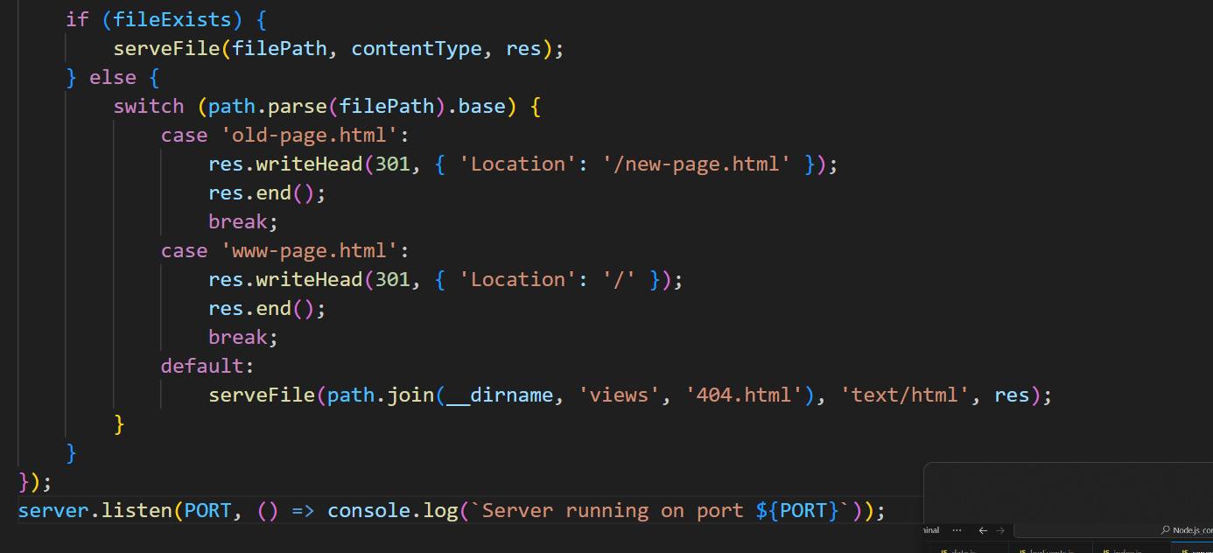

Output is

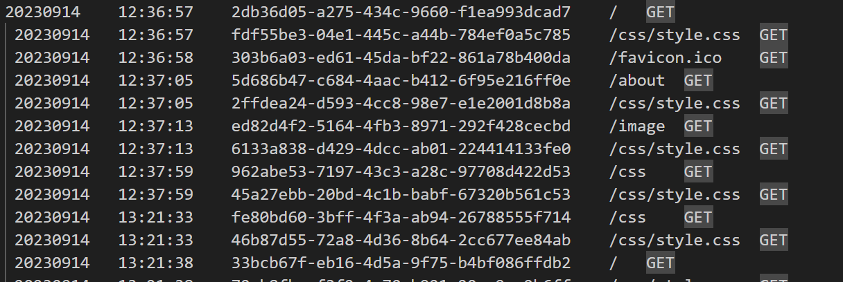

**Express.js**

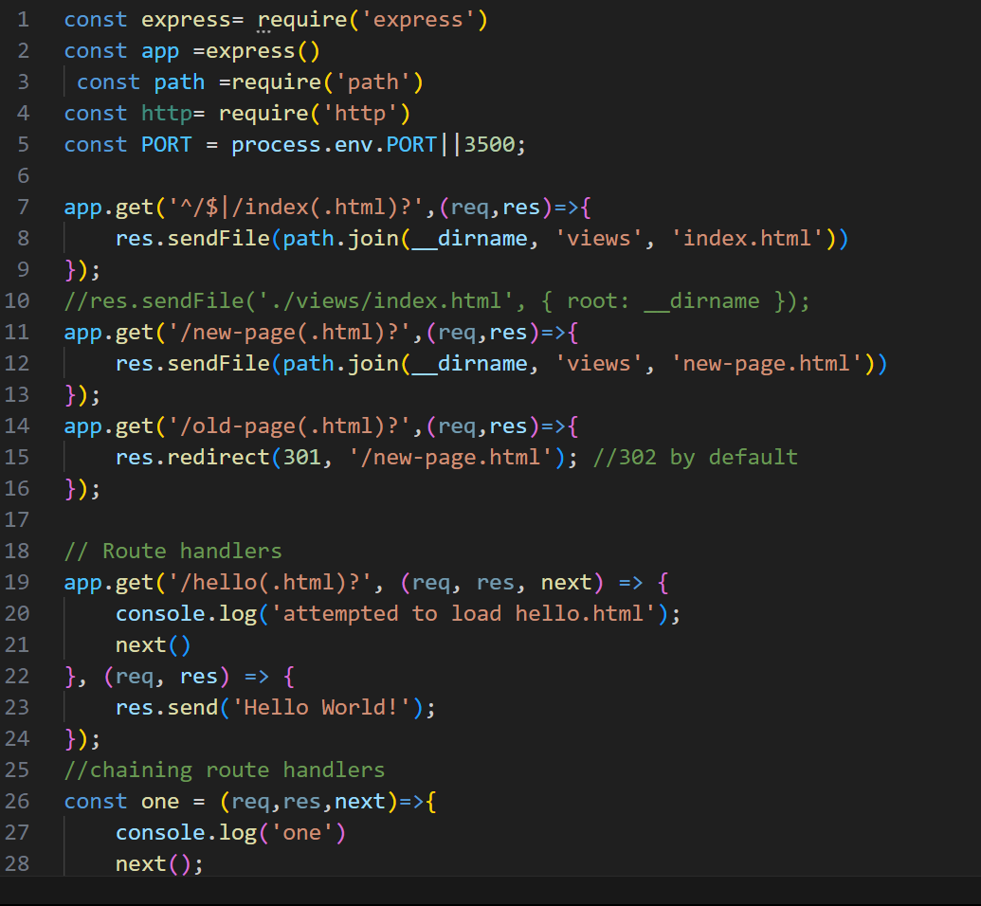

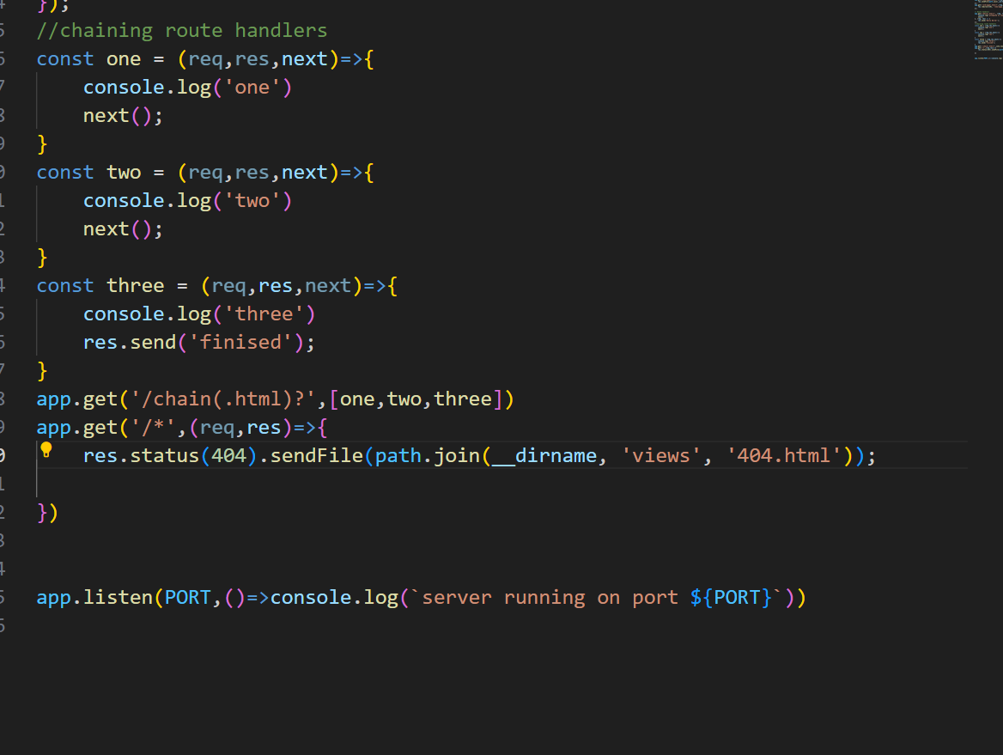

**Output**



Middleware it is code between request and reapond

All information from documentation

Globals

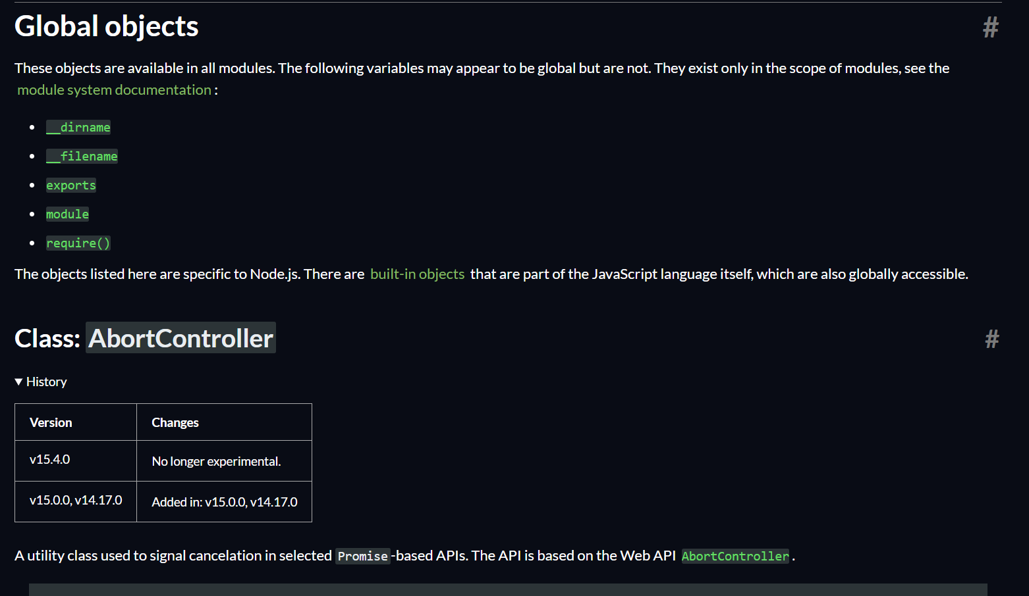

SOURCE: <https://nodejs.org/api/globals.html>